Daniel Izaguirre

Dr. Spence

Data Science

10/6/2016

PM2.5 Emissions

* Question 1:
  + Have total PM2.5 emissions decreased in the United States from 1999 to 2008?  
    Your plot(s) should show the total PM2.5 emissions (from all sources) for each of the years 1999, 2002, 2005, and 2008.

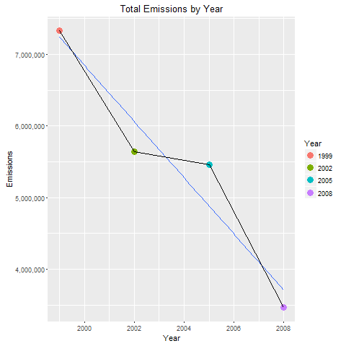

* + - Q1: Yes, in total, emissions have been declining. There was a small decline in rate from 2002 to 2006.
* Question 2:
  + Have total emissions from PM2.5 decreased in the area of Baltimore City, Maryland from 1999 to 2008? (Note the fips code for this area is “24510”.)

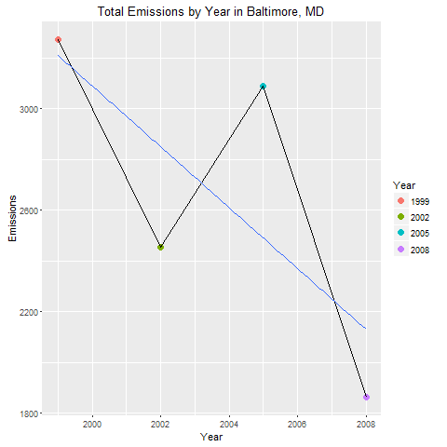

* + - Q2: Yes, total emissions from Baltimore, MD have been declining in total. However, there was a considerable spike in the year 2005. It was almost as great as the amount of emissions from the year 2000.
* Question 3:
  + The type variable identifies four types of pollutant sources (point, non-point, on-road, non-road). Of these four types of sources, which have seen emission increases in the Baltimore City area from 1999 to 2008? Which have seen emission decreases in that area during the same time period?

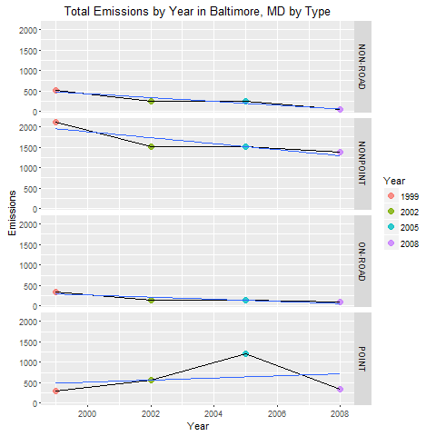

* + - Q3: There has been decline in each of the types except for Point Emissions. Point emissions were at their lowest in 1999, and have only been greater than that since then.
* Question 4
  + Compare emissions from on-road sources in Baltimore City with emissions from on-road sources in Los Angeles County, California (fips code “06037”). Which city has seen greater changes over time in on-road emissions?

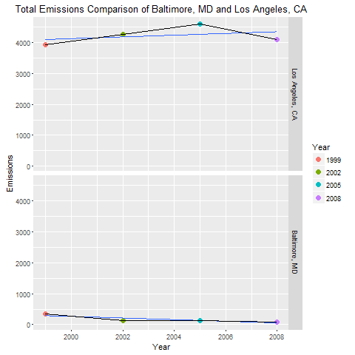

* + - Q4: Emissions have actually increased in Los Angeles, while emissions in Baltimore have been declining. However overall, Los Angeles has been emitting pollution far greater quantities of PM25 than Baltimore has.